EMAIL OPTION 1 -
Audience: CDPHP Medicare Advantage members
Subject: Need affordable prescriptions? Check out Rx for Less!
With the CDPHP Rx for Less discount program, CDPHP® Medicare Advantage members with prescription coverage can get select generic prescriptions for as little as a penny a pill when purchased at our pharmacy.
There’s never a sign-up process or registration fee, so the program is free and easy to use. Members simply present their CDPHP ID card when purchasing their prescription.
Learn more

EMAIL OPTION 2 -
Subject: We’re here to help save you money on prescriptions
Audience: CDPHP members

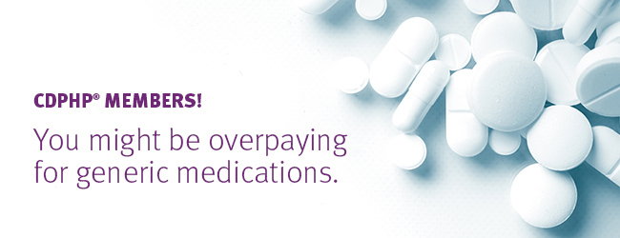
[pharmacy name] is proud to be a participating pharmacy with the CDPHP Rx for Less discount prescription program. With Rx for Less, CDPHP® members with prescription coverage can get significant discounts on specified generic drugs when purchased at preferred pharmacy locations like [insert pharmacy name]. Generic drugs are available for as little as a penny a pill!
There’s never a sign-up process or registration fee, so the program is free and easy to use. Just present your CDPHP ID card when purchasing your prescription.
Learn more!

